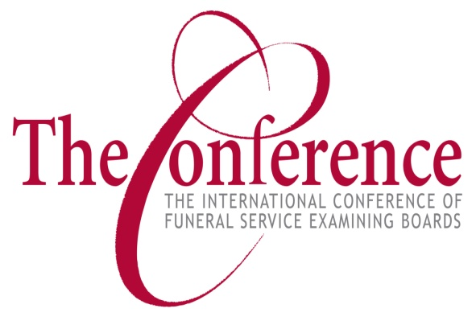
119th Annual Meeting Minutes
Wednesday – Thursday March 1-2, 2023
Chandler, AZ

Delegates in Attendance:
Charles Perine, Alabama Board of Funeral Service
Karen Carruthers, Alberta Funeral Services Regulatory Board
Natasha Culbertson, Arizona State Board of Funeral Directors and Embalmers
Amy Goode, Arkansas Board of Embalmers, Funeral Directors, Cemeteries, & Burial Services
John McGuire, District of Columbia Board of Funeral Directors
Brad Coman, Georgia State Board of Funeral Service
Brian McBride, Idaho Board of Morticians
Susan Reynolds, Iowa Department of Public Health, Bureau of Professional Licensure
Rodney McFarland, Sr., Louisiana Board of Embalmers & Funeral Directors
Robert Barnes, Maine State Board of Funeral Services
Michele Kutta, Maryland Board of Morticians and Funeral Directors
Ben Parker, Michigan Board of Examiners in Mortuary Science
Carlena Weiland, Minnesota Department of Health
Steve Brunken, Nebraska Board of Funeral Directing and Embalming
Jennifer Kandt, Nevada Funeral & Cemetery Services Board
Dr. Steven Lyons, North Carolina Board of Funeral Service
Kortney Adams, Nova Scotia Board of Registration
George Horne, Ohio Board of Embalmers & Funeral Directors
Kenneth DuPree, Pennsylvania State Board of Funeral Directors
Gay Patrick, Funeral and Cremation Services Council of Saskatchewan
Amy Holleman, South Carolina Board of Funeral Service
Randall Brennick, South Dakota Board of Funeral Service
Robert Gribble, Tennessee Board of Funeral Directors & Embalmers
Barbara Trites, Utah Board of Funeral Service
Jason Graves, Virginia Board of Funeral Directors & Embalmers
Rick Little, Washington Department of Licensing, Funeral & Cemetery Office
Linda Lyter, West Virginia Board of Funeral Service Examiners
Guy Beaudoin, Wyoming Board of Funeral Service Practitioners

I. Call to Order – Jennifer Kandt, President
President Kandt called the meeting to order at 9:03 a.m. MST.

II. Welcome – Jennifer Kandt, President
President Kandt welcomed those in attendance to Crowne Plaza Phoenix-Chandler Resort. She directed attendees to the information in the online materials and noted The Conference staff is on hand to offer assistance during the meeting.

III. Appointment of Convention Committees – Jennifer Kandt, President
President Kandt announced the following committees were appointed for the 119th Annual Meeting:

Credentials Committee Audit Committee
Jon Rettig, District 4 Director Karen Carruthers, District 8 Director
Robert Barnes, District 1 Director Robert Gribble, District 5 Director
Charles Perine, District 3 Director Blair Nelsen, District 2 Director
Rodney McFarland, District 7 Director

IV. Roll Call – Marty Rieken, Secretary/Treasurer
Mr. Rieken called the roll of member states, districts, and provinces. He reported there were 28 members represented out of the total membership of 55, which was a quorum to conduct business.

V. Introductions – Blair Nelsen, Past President
Past President Nelsen recognized the Past Presidents of The Conference and welcomed representatives from 3 national associations and 10 accredited mortuary science programs. Lastly, he introduced The Conference Board of Directors and staff. President Kandt then returned to the stage to honor Conference volunteers for their dedication and service.

VI. Finance Committee Report – Marty Rieken, Secretary/Treasurer
Mr. Rieken reported the Finance Committee reviewed and approved quarterly financial and investment reports for all four quarters of 2022. Additionally, the committee reviewed the investment policy statement recommending no changes. Lastly, the committee reviewed and approved the 2023 budget and approved an auditor for the 2022-2024 financials. It was moved and seconded to approve the finance committee report as set forth. The motion carried.

VII. Professional Policy Committee Report – Jon Rettig, Vice President
Mr. Rettig reported the Professional Policy Committee reviewed the exam administration reports, which included the number of exams given, exam development fees, exam administration costs, NBE pass rates, and other statistics. They also oversaw The Conference’s exam development meetings, reviewed the progress of the Job Task Analysis (JTA) and Standard Setting process resulting in the updated content outline and passing standards for 2023 exams. They monitored updates to the NBE score reports, approved posting statistics to the website, allowing calculator access during exams, and the issuance of individual wall certificates per exam section. They also reviewed comments and concerns submitted to The Conference and monitored the security of the exam program. It was moved and seconded to approve the professional policy committee report as set forth. The motion carried.

VIII. Exam Committee Report – Brevin Clifford, NBE Exam Committee Member
Mr. Clifford reported the Exam Committee met virtually for development meetings, an item review meeting and a forms review meeting, over the course of the past year. Four committee members participated in the in-person JTA meeting in Dallas, Texas, and five members participated in the in-person JTA meeting in Chicago, Illinois. Two committee members participated in the ABFSE Curriculum Workshop. Committee members also reviewed comments left by candidates during their exam administrations.

IX. Presentations – Jennifer Kandt, President
The morning’s panel presentation was introduced.

All Things Exam
Dan Holthus, Pearson VUE
James Ingrisone, Pearson VUE
John Runsvold, Representing ICFSEB Job Task Analysis Committee
Stephanie Gilman, Representing ICFSEB Exam Committee
Michael Grandi, Representing ICFSEB Standard Setting Committee
Jolena Grande, Representing ICFSEB Item Writer

Luncheon

District Meetings/Reports
Attendees divided into small groups by districts to discuss topics including: professional standards in funeral service, current regulatory issues facing the membership, emerging methods of disposition, and de-regulation efforts. A report from each district meeting was shared with attendees afterwards.

X. Executive Session – Jennifer Kandt, President
It was moved and seconded for Conference members to enter into executive session at 4:19 p.m. MST. Motion carried. It was moved and seconded to come out of executive session at 4:56 p.m. MST. Motion carried.

President Kandt adjourned the meeting for the day and welcomed all participants to the reception.

XI. Presentations continued – Jennifer Kandt, President
President Kandt continued the second day of the 119th Annual Meeting and introduced the next presentations:

Top Regulatory Cases
Dale Atkinson, Atkinson & Atkinson

Recipe for Success: Tell Us How You Do It
Mark Evely, Wayne State University
Jolena Grande, Cypress College
Steve Spann, John A. Gupton College
Tony Moore, Northampton Community College

Babies in the Ceiling… Wait, Did I Read That Right?
Ben Parker, Michigan Board of Mortuary Science

Policy Making & Body Raking
Dale Atkinson, Atkinson & Atkinson

Awards Luncheon

XII. Adjournment – Jennifer Kandt, President
President Kandt thanked all in attendance for their participation over the past two days and invited attendees to the 120th Annual Meeting in Myrtle Beach, South Carolina. Attendees were dismissed to attend the afternoon’s concurrent sessions.

Concurrent Sessions
Funeral Service Administrators Forum
Conference Initiatives, Conference Staff

